Presenter Questionnaire & Materials Request
* Indicates required question
Step 1: Please complete the required information.
PRESENTER INFORMATION *
Name, Job Title, Aﬃliation, Country *
Biography (approx. 100 words) *

PRESENTATION INFORMATION *
Presentation Title *
Summary of the Presentation *
PLEASE REMEMBER
This will serve as the foundation for the promotional materials (such as emails and the registration page), so please include all the necessary information to generate interest in your presentation and outline the content that will be covered.
Learning outcomes for participants *
Share 3-4 bullet points detailing the beneﬁts attendees will receive from watching your video presentation.
- …
- …
- …
- …

Who should be in attendance?
For example, list job roles or titles, etc.
Video Presentation pre-recording *
Note: view our pre-recording guidelines as part of this document to assist you with your presentation.
PLEASE REMEMBER
Recorded media (if applicable) must be submitted at least 3 weeks before the broadcast date to provide suﬃcient time for editing, reviewing, and testing. For pre-recording sessions with the BioQC team, the ﬁnal PowerPoint presentation is required 72 hours before the pre-recording date.
[ ] I would prefer to pre-record my video presentation using PowerPoint or Zoom myself.
[ ] I would like to arrange a pre-recording session via Zoom (the BioQC team will contact you to conﬁrm the date and time).
Webinar Presentation Q&A Questions
Please submit questions that are valuable for the post-presentation Q&A session.
PLEASE REMEMBER
A Q&A session after your presentation is only required for webinars, not for Expert Forums, which feature a panel discussion.

Step 2: Upload and submit using our ‘Secure File(s) Upload’ link: https://filerequestpro.com/up/bioqc-presenter
- This completed presenter questionnaire (.docx)
- Your profile photo (.gif / .png)

Step 3: If you are submitting a self-recorded video presentation, after completing it, upload and submit using our ‘Secure File(s) Upload’ link:
https://filerequestpro.com/up/bioqc-presenter
- Pre-recorded PowerPoint (.pptx) or Zoom (.mp4)
- The original PowerPoint (.pptx)

Questions?
Contact us at https://bio-qc.com/contact-us/feedback/

Video Presentation Example
- https://bio-qc.com/thanks/best-practices-for-updating-analytical-procedures-in-drug-development-and-manufacturing/

Presenter Pre-recording Guidelines

Useful to know
A wired headset (USB or audio jack) with a microphone is preferred for optimal video recording quality.
Conducting a brief test recording is wise to ensure the presentation is in Presenter Mode and the sound quality is satisfactory.
Presenters should ideally be positioned near the microphone, but not too close, and must be in a quiet room to minimise echo.

Individual Video Presentation

POWERPOINT (Self-recording)
Required software: PowerPoint 2013 / 2016 / 2019 / 2021 (https://support.microsoft.com/en-gb/office/record-a-slide-show-with-narration-and-slide-timings-0b9502c6-5f6c-40ae-b1e7-e47d8741161c)
Preparing your PowerPoint presentation correctly will help with a smooth video pre-recording process and avoid (audio and video) sync issues. See further details below in the “Important Presentation Notes” section.
Connect your ‘microphone’ (headset) to your computer.
Open the PowerPoint presentation file that contains all the slides of your presentation.
Set your PowerPoint presentation to widescreen (16:9) by going to the ‘Design’ tab, selecting ‘Slide Size,’ and choosing ‘Widescreen (16:9). Note that this may affect your design.
To start a video recording in PowerPoint, click the Record tab, select Record, choose whether to start from the beginning or the current slide and click Record again. A countdown will appear. Before starting, make sure to enable your camera. Please note that during PowerPoint video recording, you cannot blur or set a background for your webcam video.
Start the presentation by clicking the mouse or using the arrow keys to advance slides.
Make sure to finish speaking before advancing to the next slide, or the end of your narration may be cut off.
It is good practice to leave a few seconds after finishing the narration for one slide before progressing to the next.
Similarly, avoid narration during the transition from one slide to the next. Instead, allow a few seconds after the slide appears before beginning the next section of narration.
Remember that the BioQC team can eliminate any longer pauses between slides during video editing. Please note that if you do this, you must inform us which slides / parts of your presentation need video editing by the BioQC team.
The video recording will stop when you click on the final slide. Videos will be embedded in the original slide deck, one per slide. Be sure to save your file as a PowerPoint file (.pptx).
Please note that a Q&A session after your presentation is only required for webinars, not for Expert Forums, which feature a panel discussion.
- Please record the responses for your presentation’s Q&A on the final slide of your presentation, allowing a ten-second pause between each answer.
- Please provide us with a list of questions (.docx) to include in the Q&A for the final version of the presentation.
Please upload your pre-recorded video presentation in PowerPoint (.pptx), along with the original PowerPoint presentation (.pptx).
Additional resources (including PDFs and links) can be added to the event auditorium page for attendees to view and/or download directly.

Important Presentation Notes:
- Ensure no 'hidden slides' are included in your PowerPoint presentation.
- Check that your slides do not contain security warnings.
- Your presentation should not reference or include Images from a shared company network drive.
- Do not embed external content from the web, such as videos, images, fonts, etc., and avoid using animations and camera features.
- Omit hyperlinks, as our webinar platform does not support hyperlinks to external websites for security reasons.
  - Note that listed URLs within PowerPoint slides are automatically converted into hyperlinks.
  - Therefore, ensure any hyperlinks are removed and converted to plain text.
  - Please also remove any embedded hyperlinks within images.

ZOOM (Self-recording)
Required software: Zoom (https://zoom.us/download), enabling recording directly to your computer or the Zoom cloud.
Connect your ‘microphone’ (headset) to your computer.

To enable HD recording in Zoom Workplace, go to Settings > Video, check “HD” under Camera settings.
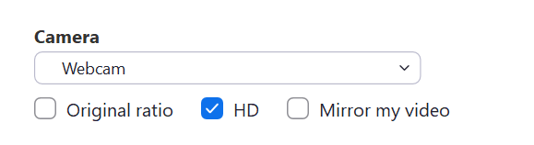
Open the PowerPoint presentation file that contains all the slides of your presentation.
Set your PowerPoint presentation to widescreen (16:9) by going to the “Design” tab, selecting ‘Slide Size,’ and choosing ‘Widescreen (16:9). Note that this may affect your design.
Launch Zoom Workplace, select ‘New meeting’ and share the screen displaying the full-screen PowerPoint slideshow.
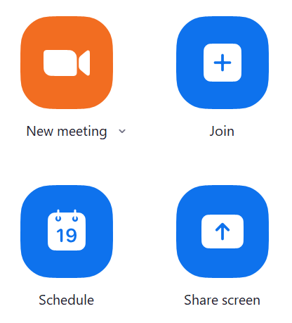
Turn on your camera (a small thumbnail video will be included in the recording). You can use a Zoom background supplied by Bio-QC or blur your background.
Maximize the size of your thumbnail video for proper recording. Do not select 'Hide Thumbnail Video,' as this will prevent the thumbnail from being recorded. If necessary, you can drag the video thumbnail to another screen.
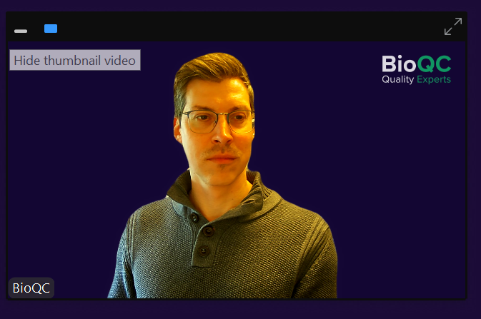
The Zoom control bar will not be recorded and can be hidden by selecting More and ‘hide floating meeting controls’.
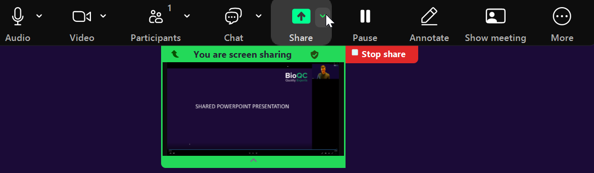
Press the record button in Zoom to start your presentation. Speak over the slides and use your arrow keys to navigate to the next slide as necessary." Make sure the full-screen presentation (Presenter Mode) is being recorded.
Ignore if there’s a little extra time at the beginning and end of the presentation, as the BioQC team can remove those portions during video editing.
Ideally, the presentation should be recorded in a single take, but we can edit it if necessary. Just indicate verbally when you want to start a sentence, change slides, or pause for a second or two.
Please note that if you do this, you must inform us which slides / parts of your presentation need video editing by the BioQC team.
Please note that a Q&A session after your presentation is only required for webinars, not for Expert Forums, which feature a panel discussion.
- Please record the responses for your presentation’s Q&A on the final slide of your presentation, allowing a ten-second pause between each answer.
- Please provide us with a list of questions (.docx) to include in the Q&A for the final version of the presentation.
Once you have recorded your presentation via Zoom, end by saving the recording to either your computer or to the Zoom cloud.
Please upload your pre-recorded video presentation in Zoom (.mp4 of both the audio and visual presentation), along with the original PowerPoint presentation (.pptx).
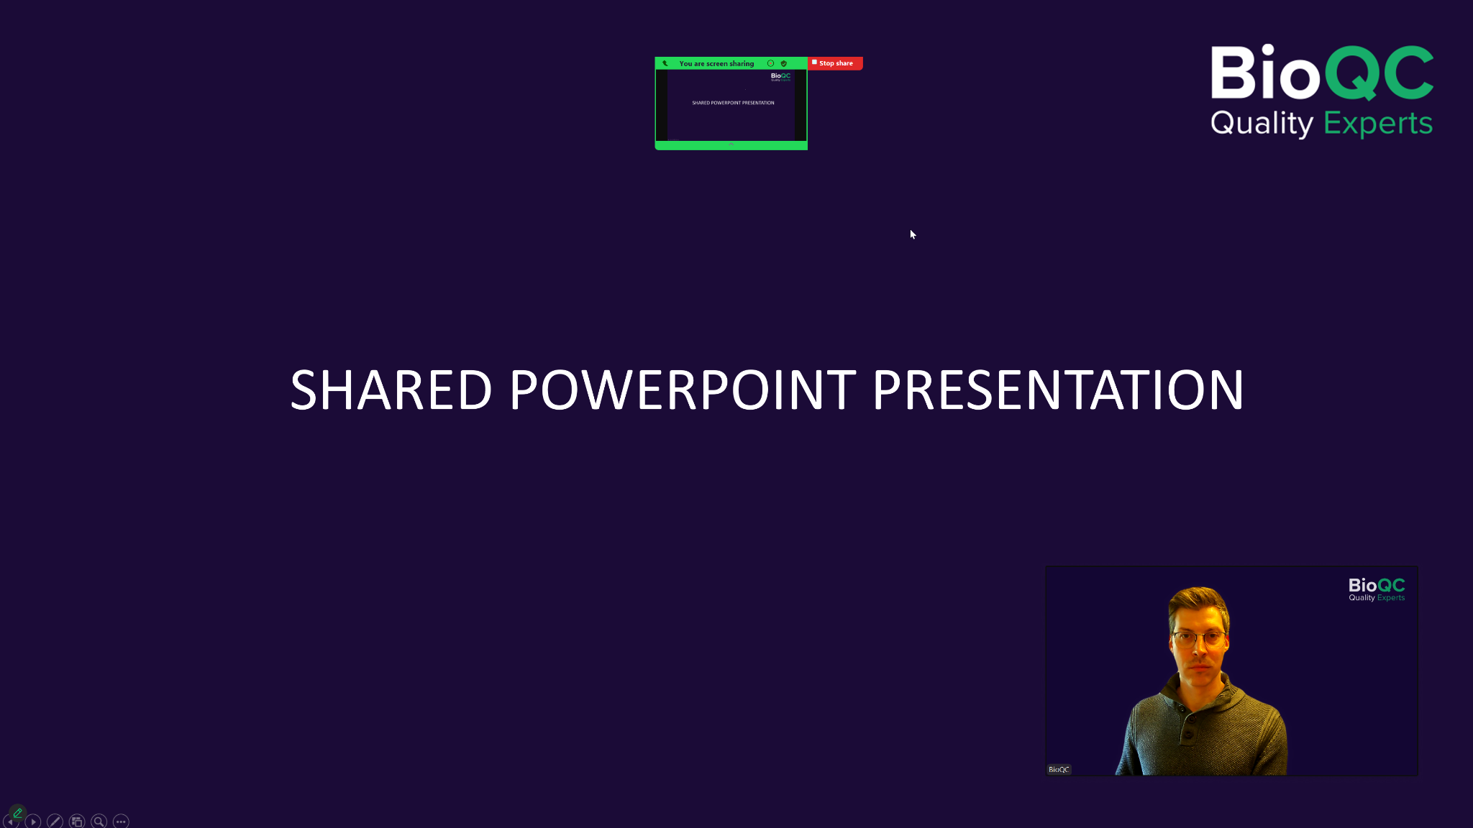

Individual Video Presentation

ZOOM (Pre-recording session with the BioQC team)
We would also be pleased to arrange a Zoom recording session with a member of the BioQC team.
Required software: Zoom (https://zoom.us/download).
Please ensure your availability on the scheduled pre-recording date and time with the BioQC team and prepare your presentation (PowerPoint or PDF) and questions for the Q&A session accordingly.
Please submit your original PowerPoint presentation (.pptx) and Q&A questions (.docx) at least 72 hours before the scheduled recording date and time.

About Us
BioQC is a global knowledge platform for scientists, researchers and innovators involved in the development and manufacturing of biopharmaceuticals and biologicals.
We deliver in-depth, expert-driven content and facilitate meaningful discussions around the challenges and innovations in CMC and related areas. From FIH studies to market approval, we support every stage of drug development with expert insights delivered via articles, eBooks, webinars, expert forums, and a thriving user community.
Learn from experts across all key disciplines involved in the lifecycle of biologics, including: Upstream Process Development (USP), Downstream Process Development (DSP), Analytical Development (AD), Product Characterisation, Formulation Development, Quality Control (QC), Quality Assurance (QA), Regulatory Affairs, CMC Management, and Manufacturing.
At BioQC, we believe that knowledge sharing accelerates progress — leading to more robust processes, faster development timelines, and safer, high-quality medicines for patients worldwide.
https://bio-qc.com/about-us/

